Darnell Chen  
Lab 7 Report  
ECE 2031 L02  
05 March 2025

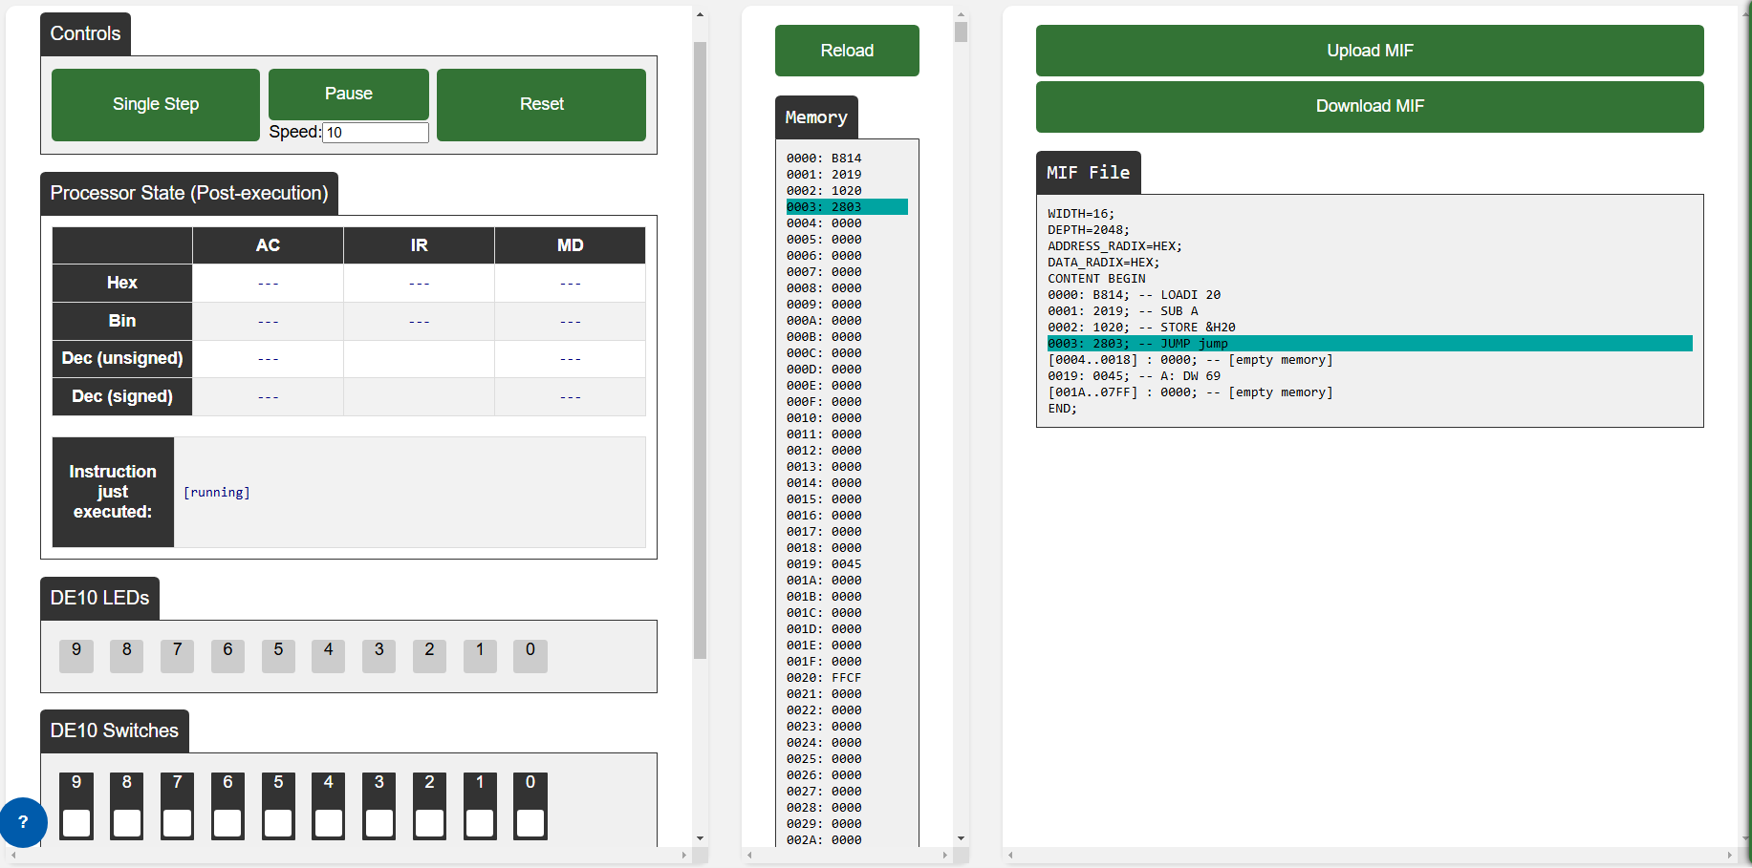

**Figure 1.** An online assembler that’s running in an infinite loop after subtracting the value 69 from 20.

-- SimpleDemo.asm

-- Code that loads the value 20 and subtracts it from the contents at memory address 0x1F before storing the result.

-- Darnell Chen

-- ECE2031 L02

-- 02/25/2025

ORG 0

LOADI 20

SUB A

STORE &H20

jump:

JUMP jump

ORG 25

A: DW 69

**Figure 2.** An assembly program code which loads the value 20 into the AC before subtracting the value stored at memory address 0x1F and storing the result in memory address 0x20.

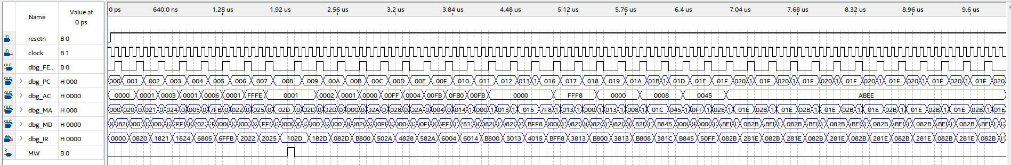

**Figure 3.** A Functional waveform simulation which runs a series of instructions. Here, we fixed our SUB and JPOS instructions correctly, which can be seen when PC is 005 and by the fact that our JPOS results in AC eventually becoming 0Xabee.

Appendix A

VHDL which implements SCOMP Assembly Instructions

-- SCOMP.VHD (VHDL)  
-- Basic implementation of SCOMP’s assembly instructions  
-- Darnell Chen  
-- ECE2031 L02  
-- 02/25/2025

library altera_mf;

library lpm;

library ieee;

use altera_mf.altera_mf_components.all;

use lpm.lpm_components.all;

use ieee.std_logic_1164.all;

use ieee.std_logic_unsigned.all;

use ieee.std_logic_arith.all;

entity SCOMP is

port(

clock : in std_logic;

resetn : in std_logic;

IO_WRITE : out std_logic;

IO_CYCLE : out std_logic;

IO_ADDR : out std_logic_vector(10 downto 0);

IO_DATA : inout std_logic_vector(15 downto 0);

dbg_FETCH : out std_logic;

dbg_AC : out std_logic_vector(15 downto 0);

dbg_PC : out std_logic_vector(10 downto 0);

dbg_MA : out std_logic_vector(10 downto 0);

dbg_MD : out std_logic_vector(15 downto 0);

dbg_IR : out std_logic_vector(15 downto 0)

);

end SCOMP;

architecture a of SCOMP is

type state_type is (

init, fetch, decode, ex_nop,

ex_load, ex_store, ex_store2, ex_iload, ex_istore, ex_istore2, ex_loadi,

ex_add, ex_addi,

ex_jump, ex_jneg, ex_jzero,

ex_return, ex_call,

ex_and, ex_or, ex_xor, ex_shift,

ex_in, ex_in2, ex_out, ex_out2, ex_sub, ex_jpos

);

-- custom type for the call stack

type stack_type is array (0 to 9) of std_logic_vector(10 downto 0);

-- internal signals

signal state : state_type;

signal AC : std_logic_vector(15 downto 0);

signal AC_shifted : std_logic_vector(15 downto 0);

signal PC_stack : stack_type;

signal IR : std_logic_vector(15 downto 0);

signal mem_data : std_logic_vector(15 downto 0);

signal PC : std_logic_vector(10 downto 0);

signal next_mem_addr : std_logic_vector(10 downto 0);

signal operand : std_logic_vector(10 downto 0);

signal MW : std_logic;

signal IO_WRITE_int : std_logic;

begin

-- use altsyncram component for unified program and data memory

altsyncram_component : altsyncram

GENERIC MAP (

numwords_a => 2048,

widthad_a => 11,

width_a => 16,

init_file => "SimpleDemo.mif",

clock_enable_output_a => "BYPASS",

lpm_hint => "ENABLE_RUNTIME_MOD=NO",

intended_device_family => "CYCLONE V",

clock_enable_input_a => "BYPASS",

lpm_type => "altsyncram",

operation_mode => "SINGLE_PORT",

power_up_uninitialized => "FALSE",

read_during_write_mode_port_a => "NEW_DATA_NO_NBE_READ",

outdata_reg_a => "UNREGISTERED",

outdata_aclr_a => "NONE",

width_byteena_a => 1

)

PORT MAP (

wren_a => MW,

clock0 => clock,

address_a => next_mem_addr,

data_a => AC,

q_a => mem_data

);

-- use lpm function to shift AC

shifter: lpm_clshift

generic map (

lpm_width => 16,

lpm_widthdist => 4,

lpm_shifttype => "arithmetic"

)

port map (

data => AC,

distance => IR(3 downto 0),

direction => IR(4),

result => AC_shifted

);

-- Memory address comes from PC during fetch, otherwise from operand

with state select next_mem_addr <=

PC when fetch,

operand when others;

-- This makes the operand available immediately after fetch, and also

-- handles indirect addressing of iload and istore

with state select operand <=

mem_data(10 downto 0) when decode,

mem_data(10 downto 0) when ex_iload,

mem_data(10 downto 0) when ex_istore2,

IR(10 downto 0) when others;

-- use lpm tri-state driver to drive i/o bus

io_bus: lpm_bustri

generic map (

lpm_width => 16

)

port map (

data => AC,

enabledt => IO_WRITE_int,

tridata => IO_DATA

);

IO_ADDR <= IR(10 downto 0);

IO_WRITE <= IO_WRITE_int;

process (clock, resetn)

begin

if (resetn = '0') then -- Active-low asynchronous reset

state <= init;

elsif (rising_edge(clock)) then

case state is

when init =>

MW <= '0'; -- clear memory write flag

PC <= "00000000000"; -- reset PC to the beginning of memory, address 0x000

AC <= x"0000"; -- clear AC register

IO_WRITE_int <= '0'; -- don't drive IO

state <= fetch; -- start fetch-decode-execute cycle

when fetch =>

IO_WRITE_int <= '0'; -- lower IO_WRITE after an out

PC <= PC + 1; -- increment PC to next instruction address

state <= decode;

when decode =>

IR <= mem_data; -- latch instruction into the IR

case mem_data(15 downto 11) is -- opcode is top 5 bits of instruction

when "00000" => -- no operation (nop)

state <= ex_nop;

when "00001" => -- load

state <= ex_load;

when "00010" => -- store

state <= ex_store;

when "00011" => -- add

state <= ex_add;

when "00101" => -- jump

state <= ex_jump;

when "00110" => -- jneg

state <= ex_jneg;

when "01000" => -- jzero

state <= ex_jzero;

when "01001" => -- and

state <= ex_and;

when "01010" => -- or

state <= ex_or;

when "01011" => -- xor

state <= ex_xor;

when "01100" => -- shift

state <= ex_shift;

when "01101" => -- addi

state <= ex_addi;

when "01111" => -- istore

state <= ex_istore;

when "01110" => -- iload

state <= ex_iload;

when "10000" => -- call

state <= ex_call;

when "10001" => -- return

state <= ex_return;

when "10010" => -- in

state <= ex_in;

when "10011" => -- out

state <= ex_out;

IO_WRITE_int <= '1'; -- raise IO_WRITE

when "10111" => -- loadi

state <= ex_loadi;

when "00100" =>

state <= ex_sub; -- subtract

when "00111" =>

state <= ex_jpos;

when others =>

state <= fetch; -- invalid opcodes don't execute

end case;

when ex_nop =>

state <= fetch;

when ex_load =>

AC <= mem_data; -- latch data from mem_data (memory contents) to AC

state <= fetch;

when ex_store =>

MW <= '1'; -- drop MW to end write cycle

state <= ex_store2;

when ex_store2 =>

MW <= '0'; -- drop MW to end write cycle

state <= fetch;

when ex_add =>

AC <= AC + mem_data; -- addition

state <= fetch;

when ex_jump =>

PC <= operand; -- overwrite PC with new address

state <= fetch;

when ex_jneg =>

if (AC(15) = '1') then

PC <= operand; -- Change the program counter to the operand

end if;

state <= fetch;

when ex_jzero =>

if (AC = x"0000") then

PC <= operand;

end if;

state <= fetch;

when ex_and =>

AC <= AC and mem_data; -- logical bitwise AND

state <= fetch;

when ex_or =>

AC <= AC or mem_data;

state <= fetch;

when ex_xor =>

AC <= AC xor mem_data;

state <= fetch;

when ex_shift => -- shift is accomplished with a dedicated shifter

AC <= AC_shifted;

state <= fetch;

when ex_addi =>

-- sign extension

AC <= AC + (IR(10) & IR(10) & IR(10) &

IR(10) & IR(10) & IR(10 downto 0));

state <= fetch;

when ex_call =>

for i in 0 to 8 loop

PC_stack(i + 1) <= PC_stack(i);

end loop;

PC_stack(0) <= PC;

PC <= operand;

state <= fetch;

when ex_return =>

for i in 0 to 8 loop

PC_stack(i) <= PC_stack(i + 1);

end loop;

PC <= PC_stack(0);

state <= fetch;

when ex_iload =>

-- indirect addressing is handled in next_mem_addr assignment.

state <= ex_load;

when ex_istore =>

MW <= '1';

state <= ex_istore2;

when ex_istore2 =>

MW <= '0';

state <= fetch;

when ex_in =>

IO_CYCLE <= '1';

state <= ex_in2;

when ex_in2 =>

IO_CYCLE <= '0';

AC <= IO_DATA;

state <= fetch;

when ex_out =>

IO_CYCLE <= '1';

state <= ex_out2;

when ex_out2 =>

IO_CYCLE <= '0';

state <= fetch;

when ex_loadi =>

AC <= (IR(10) & IR(10) & IR(10) &

IR(10) & IR(10) & IR(10 downto 0));

state <= fetch;

when ex_sub =>

AC <= AC - mem_data;

state <= fetch;

when ex_jpos =>

if (AC(15) = '0') and (AC /= x"0000") then

PC <= operand;

end if;

state <= fetch;

when others =>

state <= init; -- if an invalid state is reached, reset

end case;

end if;

end process;

-- Additional outputs to aid simulation

dbg_FETCH <= '1' when state = fetch else '0';

dbg_PC <= PC;

dbg_AC <= AC;

dbg_IR <= IR;

dbg_MA <= next_mem_addr;

dbg_MD <= mem_data;

end a;

Appendix B

Assembly which compares and returns the larger beginning and ending nibble of a value

-- BitComparator.asm  
-- A program that compares the lowest and highest nibbles of a value, and returns whichever is larger

-- Darnell Chen  
-- ECE2031 L02  
-- 02/25/2025

ORG 0

LOAD VALUE

AND LSBBITS

STORE LSB

LOAD VALUE

SHIFT -12

AND LSBBITS

STORE MSB

SUB LSB

JNEG LsbLarger

JPOS MsbLarger

LsbLarger:

LOAD LSB

STORE RESULT

Jump Finish

MsbLarger:

LOAD MSB

STORE RESULT

JUMP Finish

Finish:

JUMP Finish

ORG 200

VALUE: DW &HF00E

LSB: EQU 512

MSB: EQU 516

RESULT: EQU 1024

LSBBITS: DW &H000F